INT 374
PROJECT REPORT
(Project Semester August-January 2024)

NATIONAL AQI MONITORING SYSTEM

Submitted by
Harsh Chauhan

Registration No : 12319734

Programme and Section: B.Tech (K23HK)
Course Code : 374 (INT)

Under the Guidance of

(Name of faculty coordinator with U.Id and designation)
Ms. Sadaf Qureshi (32988)
Discipline of CSE/IT

School of Computer Science and Engineering

Lovely Professional University, Phagwara

CERTIFICATE

This is to certify that Harsh Chauhan (student’s name) bearing Registration no. 12319734 has completed INT 374 project titled, “National AQI Monitoring System” under my guidance and supervision. To the best of my knowledge, the present work is the result of his/her original development, effort and study.

Signature and Name of the Supervisor
Designation of the Supervisor
School of Computer Science Engineering
Lovely Professional University
Phagwara, Punjab.
Date:

DECLARATION

I, Harsh Chauhan, student of B.Tech (Computer Science and Engineering) under CSE/IT Discipline at, Lovely Professional University, Punjab, hereby declare that all the information furnished in this project report is based on my own intensive work and is genuine.

Date: 12/04/2025 Harsh Chauhan
Registration No. 12319734 Name of the student

ACKNOWLEDGEMENT

I would like to express my sincere gratitude to Ms. Sadaf Qureshi mam for their invaluable guidance and support throughout this project. Their insights and expertise have greatly contributed to the successful completion of this research.
I extend my appreciation for providing essential resources and encouragement during this study. Their constructive feedback and suggestions have been instrumental in refining our analysis.
I would also like to thank him for their continuous motivation and assistance in various aspects of this project. Lastly, I am grateful for their unwavering support and belief in my abilities.
This project would not have been possible without the collective efforts of all those who contributed in different ways

Thank You Mam

Table of Content

Index | Title | Page Number
1 | Abstract | 5
2 | Introduction | 6
3 | Methodology | 8
4 | Result and Evaluation | 13
6 | Conclusion | 16
7 | Project Images | 17
8 | Links | 36
9 | References | 37

1. Abstract
This project presents a real-time National Air Quality Index (AQI) Monitoring System developed using Power BI. The system uses live hourly air quality data provided by the Government of India through the dataset “Real-Time Air Quality Index from various locations | Open Government Data (OGD) Platform India” available on data.gov.in.
Since the API provides only the latest hourly reading, a custom GitHub Actions workflow was built to automatically fetch and store the data hourly in a GitHub repository, enabling historical trend analysis. Power BI is connected to this continuously updated dataset to generate real-time dashboards that display pollution levels across cities, AQI categories, pollutant concentrations, and station-wise AQI information.
The project demonstrates the use of automated data collection, data modelling, DAX analytics, and interactive visualization to create a scalable and real-time environmental monitoring system for India.

2. Introduction
Air pollution has become one of India’s most critical environmental challenges. To understand and evaluate air quality patterns, real-time monitoring is essential. The Government of India publishes air quality data through the Open Government Data (OGD) platform, but the platform provides only the most recent hour's data, making historical analysis difficult.
This project aims to solve that challenge by building a centralized, automated, and visual monitoring system using Power BI. The system collects data hourly, stores it for history, and displays current AQI conditions across the country.
Objectives:
- To develop a real-time AQI dashboard for India.
- To automate data collection using GitHub Actions (hourly fetch).
- To visualize AQI distribution across states, cities, and pollutants.
- To identify the most polluted and cleanest cities in real time.
- To help users understand pollution trends through interactive analytics.
The final dashboard provides valuable insights for citizens, researchers, policymakers, and environmental analysts.

3. Methodology
3.1 Data Source
- Source: data.gov.in
- Dataset Name: Real-Time Air Quality Index from various locations – OGD Platform India
- API: Provides current hour readings from 500+ monitoring stations across India.
- Attributes include:
  - station_code, state, city, pollutant_id,
  - pollutant_avg, pollutant_min, pollutant_max,
  - aqi, aqi_category, last_update.
3.2 Real-Time Data Pipeline (GitHub Actions)
Since the government API only provides live hourly data, GitHub Actions was implemented to build a “data recorder”.
Process:
- A scheduled GitHub Action runs every hour.
- The workflow calls the OGD API and fetches the latest AQI readings.
- The data is appended to a CSV file in the GitHub repository.
- The dataset becomes a continuously growing historical dataset.
- Power BI is connected to this GitHub file using Power BI Web Connector.
This method converts a real-time API into a historical time-series dataset.
3.3 Data Cleaning & Preparation
- Removed duplicate hourly entries.
- Converted timestamps to IST.
- Standardized pollutant names (PM2.5, PM10, NO2, SO2, CO, OZONE, NH3).
- Created data model relationships:
  - Stations → Cities → States
  - Pollutants → AQI Category
- Added custom calculated columns like:
  - Daily Avg AQI
  - City-wise Mean Pollutant Levels
  - AQI Category Bucket
3.4 DAX Measures Used
Examples:
- AQI Avg Today
AQI Avg Today = AVERAGE('air_quality_dataset'[aqi])
- Most Polluted City
Most Polluted City =
VAR CityAQI =
SUMMARIZE('air_quality_dataset', 'air_quality_dataset'[city],
"AvgAQI", AVERAGE('air_quality_dataset'[aqi]))
VAR TopCity = TOPN(1, CityAQI, [AvgAQI], DESC)
RETURN MAXX(TopCity, [city])
- Cleanest City (minimum AQI by city).
3.5 Visualization & Dashboard Design
Power BI visuals include:
- KPI Cards (AQI Avg, Most Polluted City, Cleanest City)
- Top 10 Polluted Cities (Bar Chart)
- Pollutant Contribution (Stacked Bar)
- AQI Category Distribution (Donut Chart)
- Real-Time AQI Map of India (ArcGIS map)
- Filters for State, Pollutant, Category, and Station Code
Interactive slicers allow the user to analyze air quality with multiple perspectives.

4. Results and Evaluation
4.1 Key Insights Found
- Most polluted cities consistently show higher PM2.5 and PM10 levels.
- Northern India displayed higher concentration of particulate matter.
- Southern and North-East cities often fall into “Good” or “Satisfactory” categories.
- NO2 and OZONE show significant variation by industrial belts.
- Real-time map gives clear hotspots with color-coded AQI bubbles.
4.2 Dashboard Performance
- Real-time refresh using GitHub data enables updates every hour.
- Optimized star-schema model ensures fast filtering in Power BI.
- DAX measures efficiently calculate averages and rankings.
4.3 Evaluation of the Data Pipeline
- GitHub Actions proved reliable for hourly recording.
- No need for a costly cloud database.
- Historical data enables long-term analysis that was not available from the API directly.
4.4 Limitations
- API sometimes misses data for some stations.
- Only hourly data is available (no minute-level data).
- GitHub storage is limited; long-term archiving needs cleanup or cloud migration.

5. Conclusion
The National AQI Monitoring System successfully transforms real-time government API data into a meaningful and interactive Power BI dashboard. By creating an automated data pipeline using GitHub Actions, the project overcomes the limitation of the API providing only the latest hour's readings.
The system provides actionable insights, identifies pollution hotspots, tracks pollutant trends, and enables comparisons across cities and states.
This real-time AQI dashboard can be extended further into:
- Predictive modelling (forecasting AQI).
- Alert systems for high pollution levels.
- Integration with IoT sensors.
- Mobile app or web dashboard deployment.
Overall, the project demonstrates an effective combination of automation, data engineering, analytics, and visualization to build a reliable environmental monitoring solution for India.

- Project Images

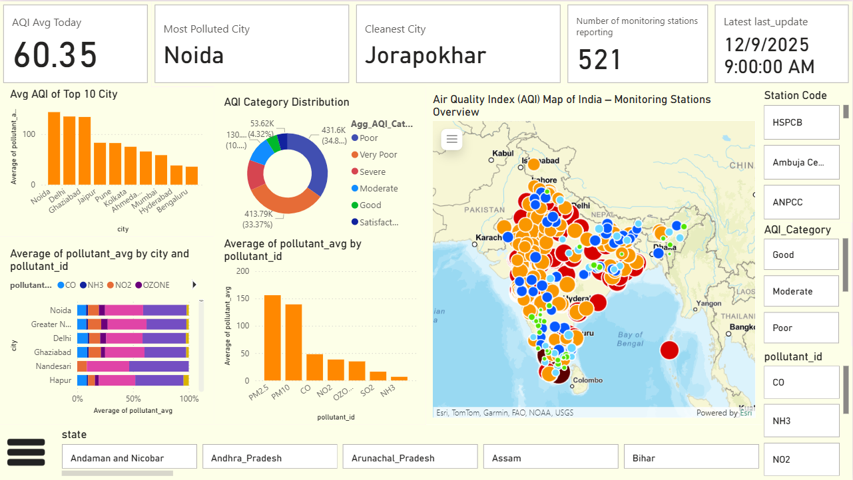

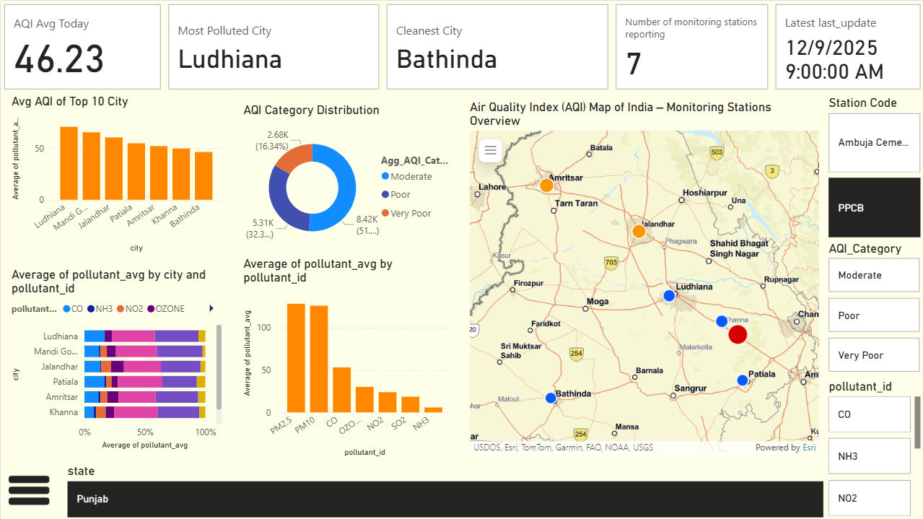

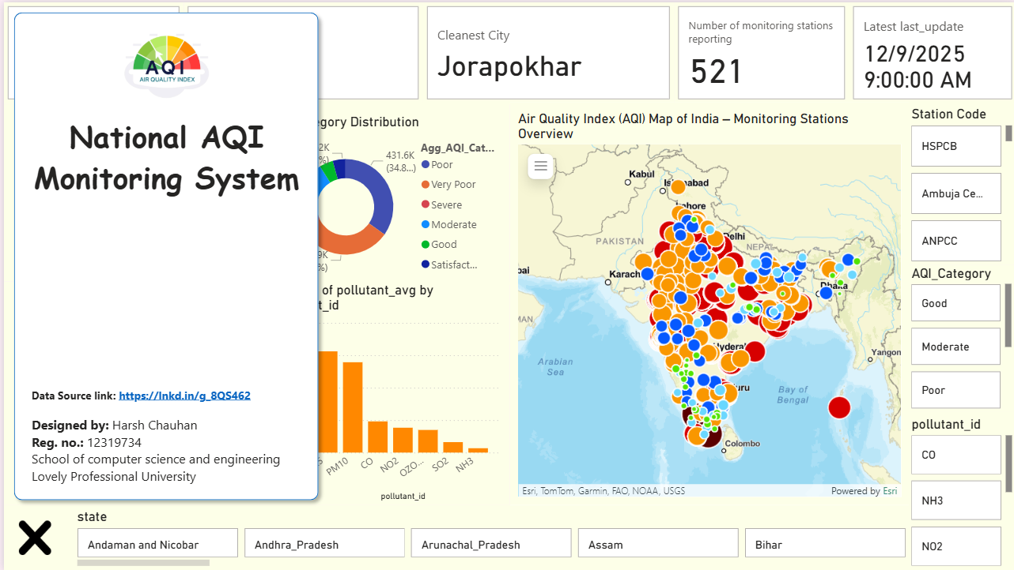

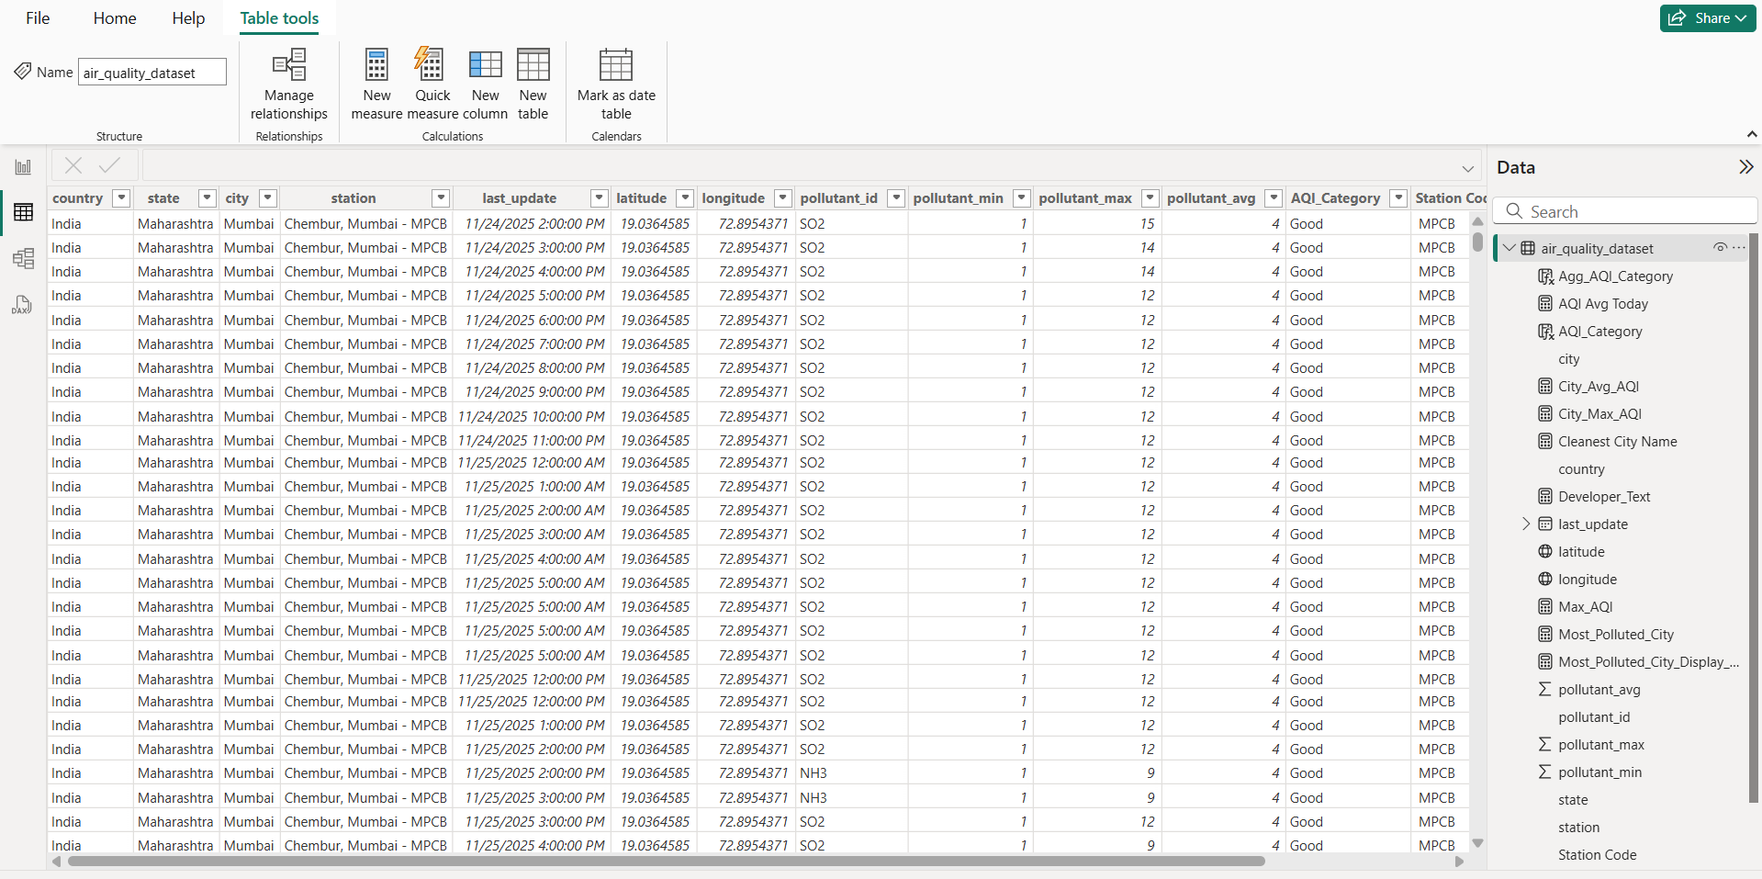

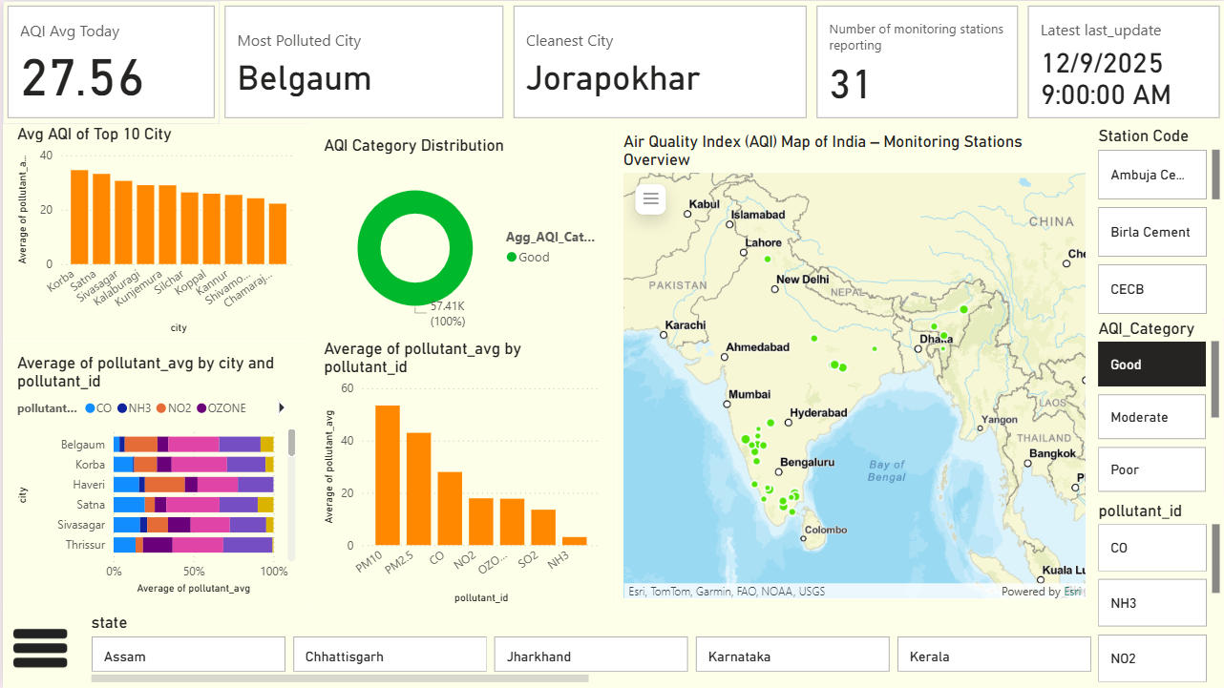

+
References
- Open Government Data (OGD) Platform India – Real-Time Air Quality Index from various locations.
https://data.gov.in
(Dataset: Real-Time Air Quality Index from various locations)Scikit-learn: Machine Learning in Python
Pedregosa, F., Varoquaux, G., Gramfort, A., Michel, V., Thirion, B., Grisel, O., ... & Duchesnay, É. (2011).
- Central Pollution Control Board (CPCB), Government of India.
National Air Quality Index (AQI) Standards.
https://cpcb.nic.in/air-quality/
Chollet, F. (2017). Deep Learning with Python. Manning Publications. https://www.manning.com/books/deep-learning-with-python
- Ministry of Environment, Forest and Climate Change (MoEFCC) – Air Quality Monitoring Reports.
https://moef.gov.in/
Links :
Github Link : https://github.com/harshchauhan01/Air-Quality-Analyzer/
Linkedin Link : https://www.linkedin.com/in/harshchauhan7534/
Dataset link: https://raw.githubusercontent.com/harshchauhan01/Air-Quality-Analyzer/refs/heads/main/weather_data.csv

Linkedin and Github Posts

